**How to set onPress on a View in React Native**

In this post, we will see How to set onPress on a View in React Native. While working with React Native components we need to set onPress on different situations to do that we have to surround it with the React Native Touchables but what if we can set onPress on the View container itself. You can do this using *onStartShouldSetResponder*(This will work only after React Native version -> 55.3). So let’s see the example.

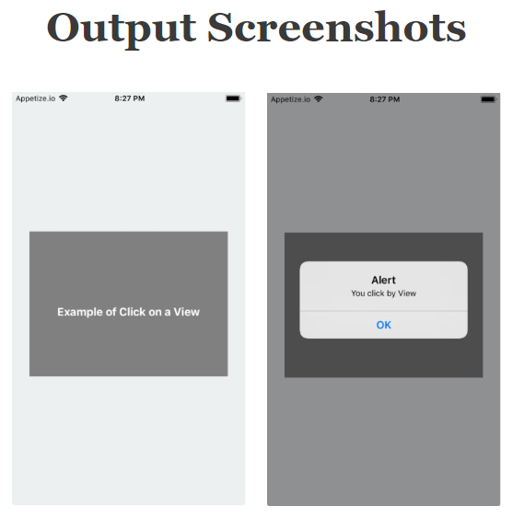

// This is an Example to set onPress on a View in React Native

//This example will work only after React Native version > 55.3

import * as React from 'react';

import { Text, View, StyleSheet } from 'react-native';

export default class App extends React.Component {

render() {

return (

<View style={styles.container}>

<View

style={styles.innerView}

onStartShouldSetResponder={() => alert('You click by View')}>

<Text style={styles.paragraph}>Example of Click on a View</Text>

</View>

</View>

);

}

}

const styles = StyleSheet.create({

container: {

flex: 1,

justifyContent: 'center',

paddingTop: 25,

backgroundColor: '#ecf0f1',

padding: 8,

},

innerView: {

flex: 1,

justifyContent: 'center',

paddingTop: 25,

backgroundColor: '#808080',

marginTop: 200,

marginBottom: 200,

marginLeft: 20,

marginRight: 20,

},

paragraph: {

margin: 24,

fontSize: 18,

color:"white",

fontWeight: 'bold',

textAlign: 'center',

},

});